Concept Proposal

# Genre

Surreal, exploration- and dialogue-focused role-playing game with puzzle/escape room elements.

# Aesthetic

3D, dreamlike, use of photogrammetry for photorealism to be betrayed by scale difference and deformation, with a calm, quiet, textury soundtrack.

# Story

A simple doll wakes in a dark dream full of miscellaneous, oddly scaled objects and out of place scraps of scenery. Figurines among the objects pose riddles, puzzles, or simple conversations to the doll, which when solved enable it to ascend a dark spiral, until reaching to top and waking.

# Construction

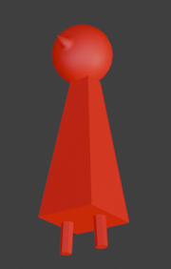

My doll figure, as described -- a circular head with a conic nose, positioned over the tip of a square-pyramid body with short cylindrical legs. Red.)

Most assets will be produced via photogrammetry, but the protagonist will be a simple polygonic red doll prefab i'made years ago and have used in many projects, mostly for testing purposes. I'll also model some structural elements – i'm thinking just lumpy dark matter, primarily a spiraling ramp with connected platforms. i want this matter to mostly blend with shadows, although with a wetlike gloss, like sludgy resin.

# Inspiration

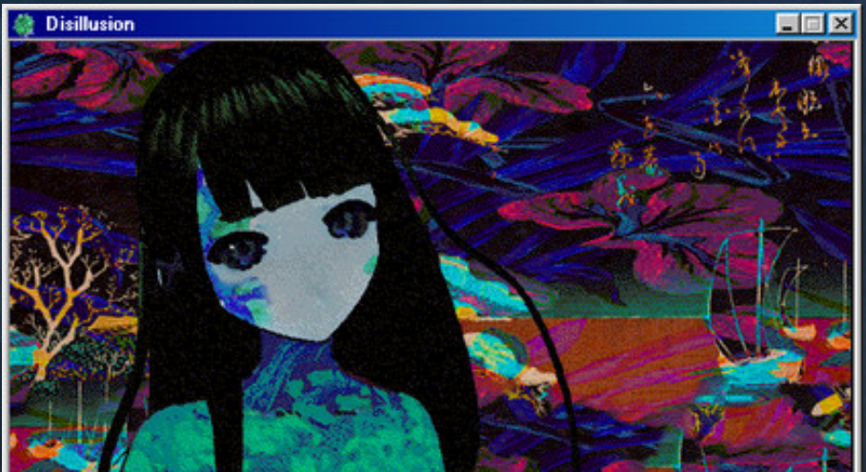From Disillusion (2018), featuring its character Melpomene standing in front of a colorful digital collage

My main inspiration here is [*Disillusion*](https://store.steampowered.com/app/1490060/Disillusion/) (2021; and [its in-development sequel](https://disillusionst.itch.io/disillusion-st)), as well as other games that, like it, take after *LSD: Dream Emulator* (1998)*,* such as *Yume Nikki* (2004). i really liked how much dialogue *Disillusion* involved and how surreal, even meaningless much of it was. i also liked that it's a bit less simply wandery, as you're passing up and out a tower (which is also hell.) i like the climbing aspect, like Dante's *Divine Comedy*.

i want this game to be overall lighter, shorter, less dependent on mythological references as *Disillusion* is, more focused on dialogue which was what i thought made that game so innovative to its genre, but also with some 3D puzzle elements to give the player something to focus on in between interactions. i also love *Disillusion*'s soundtrack, very pretty and skilled multi-instrumental music composed and created by the game's creator, who is also a pretty skilled classical guitarist.

Unlike *Disillusion* and more like other dream emulator games, i want this game to very obviously be simply a simulation of a dream, a dream of my own. Photogrammetry provides me a fun opportunity to take imagery from my real life to incorporate as mnemonic residue into this dream.

Planning and Timeline

# Level Description

Dark, horizontally relatively small (~30m) but vertically multi-leveled (3, mainly) accessed via a dark but glossy spiraling platform and extensions like floating islands connected by paths, the floor elements all looking like a solid structure of dark mud. The player, controlling a doll with a light at its feet, must solve riddles or puzzles to pass obstacles on the spiral, requiring them to communicate with other dolls and pay attention to the miscellanious objects.

# Visual Elements

**Modeled from scratch:**

* **protagonist** – red doll model i already have (see Concept Proposal)
* **floor layout** as described above
* **ui elements** – dialogue boxes, start and end cards

**Made via photogrammetry:**

* **scenery objects** – some **interactable**:
  + These include models i've already made for class, which are miscellanious objects and scenery taken at the University of Baltimore and at my home
  + Many of them will be **dolls** that the player can interact with
  + **Tone/Aesthetic**: dreamy, sleepy, dark

# Tasks

* **Modeling/Designing** all the visual elements described above
* **Scripting**:
  + **object interactions** – dialogue, player movement, level progression actions (such as opening a gate, moving objects, etc.
    - **OnCollisionStop –** prevent colliders from entering each other; attach to doll
  + **player movement** – WASD to move around horizontally, spacebar for jumping (can jump on air as well for continuous jumps)
  + **camera controls** –
    - isometric view that follows the player but doesn't rotate
      * can zoom in/out via mouse controls:
      * drag two fingers on touchpad toward each other to zoom in our away from each other to zoom out;
      * mouse scroll wheel forward to zoom in or backward to zoom out;
      * right click hold and drag to zoom in/out;
      * have a max zoom-out set to prevent player from seeing ahead
    - **stretch goal**: left click down opens another view that shows the protagonist's view facing whatever the mouse has clicked on
  + **game win state** – when the player reaches the top, game over

# Timeline

**Milestone 1 (2024-11-18):**

* Model out the scene floorplan
* Collect (photogrammetry) and refine model assets (toys, scenery reliefs)
* Finalize object interactions and obstacle solutions plans

**Milestone 2 (2024-11-25):**

* Add objects to scene
* Refine lighting, materials etc.
* Complete UI elements

**Milestone 3 (2024-12-02):**

* Script everything – objects, player controls, camera
* **stretch goal:** Add music (Creative Commons-licensed / Public Domain)
* Build for playtesting

**Milestone 4 (Final, 2024-12-09):**

* Final build after playtesting